**PLEASANT GROVE**

**TEAM HANDBALL STUDY GUIDE**

**HISTORY**

Team handball originated in the Scandinavian countries in the early 1900s as a field sport using 11 players per team. Because of severe winters, the game was modified to become an indoor sport in the later 1920s and teams are made up of 7 players. Team handball was included in the Olympic Games for men in 1972 and for women in 1976 which gave an added boost to the sport’s popularity. Team handball is a relatively simple game, which makes it possible to enjoy playing almost immediately. The game combines the fundamental skills of running, jumping, catching, and throwing into a continuous fast-moving sport, making it a good activity to promote cardiorespiratory health. Skills mimic soccer, basketball, hockey, speedball, and water polo making it easy for beginners to be successful.

**OBJECTIVE**

The object of team handball is to score a goal by passing the ball quickly and throwing the ball past the defense and goalie into the goal. A regulation game consists of 2 30-minute halves with a 10 minute intermission. The only breaks in the game occur when an injury occurs.

**RULES**

1. A team shall consist of a 1 goalie and 6 court players – left & right wing, circle runner, left, right & center backcourt .
2. Play begins with a center throw-off (sometimes called a throw-on) by one team determined by a coin toss or Ro-Sham-Bo.
3. Both teams must begin on their own half of the court.
4. A goal is worth 1 point. In a regulation game the entire ball must cross the goal line for the point to count.
5. After a goal is scored a center throw-off is awarded to the opposing team.
6. Sidelines are in play.
7. Court players may do the following:
   * Hold the ball up to 3 seconds
   * Run 3 steps with the ball
   * Dribble as many times as desired
   * Pass or shoot
   * Run 3 steps before and after a dribble
8. Court players **may not** do the following:
   * Use their arms or legs to push, grab, tackle, kick or hold on opponent
   * Kick the ball
   * Make contact with the ball below the knees
   * Double dribble
   * Step on or across the goal area line
   * Air dribble
9. Goalies may do the following:
   * Defend the goal in any way using hands, feet and body
   * Take more than 3 steps when carrying the ball in the goal
   * Hold the ball longer than 3 seconds
   * Move outside the goal area and throw for a goal, but must abide by the rules for court players
10. Goalies **may not** do the following:
    * Leave the goal area while in possession of the ball
    * Pick up a ball outside the goal area and carry it back into the goal area

**STRATEGIES**

Basic 1-on-1 and zone defenses are used in the game. Beginners will be most successful using a 1-on-1 defense. Bounce passes are most effective when moving the ball between players. Basketball and soccer offensive and defensive strategies can be used quite easily in team handball.

**VOCABULARY**

1. **Assist**: a pass that directly leads to a goal by a teammate
2. **Checking**: attempting to prevent an opponent from gaining an advantage (body checking)
3. **Crease**: this is the half circle/rectangular box in front of the goal (goal box)
4. **Clearing**: sending the handball out of the attack zone
5. **Dribbling**: moving the ball around by bouncing the ball with one hand maintaining control
6. **Throw-off**: starts the game and follows each goal
7. **Throw-in:** taken from the sideline after the ball travels out of bounds
8. **Goa**l: a handball that is scored inside the goal area
9. **Goal-throw:** a throw made by the goalie from outside the goal area upon retrieving a loose ball outside the goal area
10. **Throw-out**: a throw made by the goalie if the ball is caught or blocked inside the goal
11. **Free-throw**: awarded for a rule violation by the goalie or a court player. The free-throw is taken closest to where the violation occurred.

**Diagram of Team Handball Court**

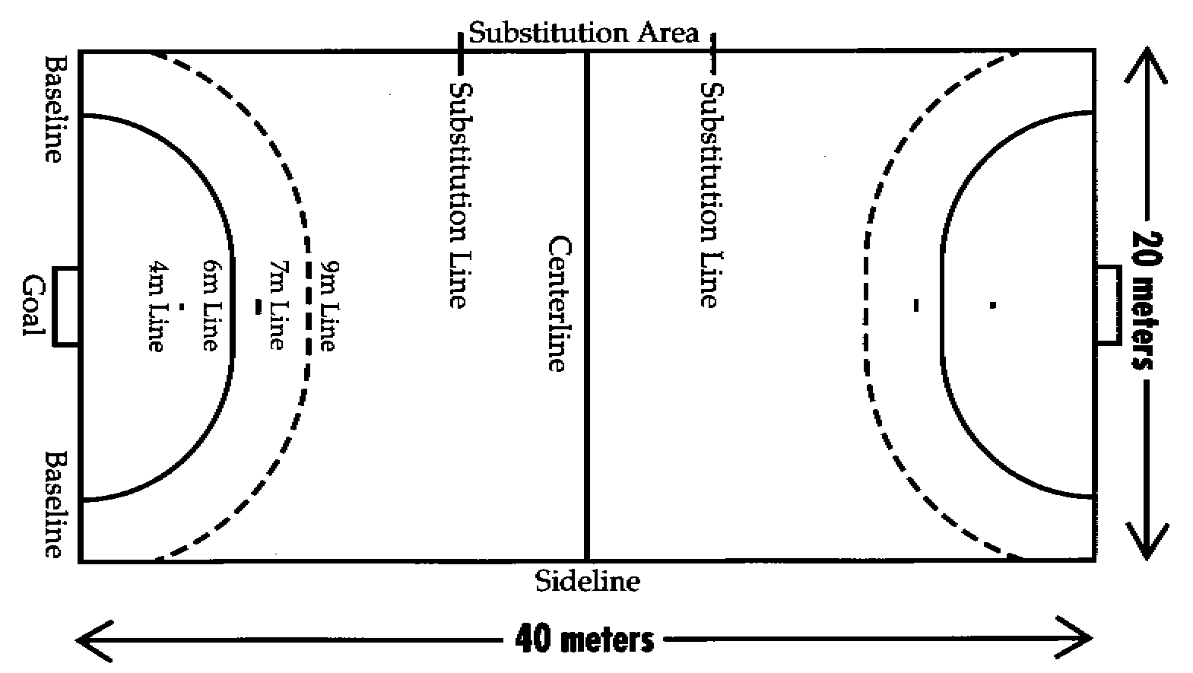

Diagram of a team handball court is from the web site for   
USA Team Handball ([http://www.usateamhandball.org/](http://www.usateamhandball.org)